Detailed Design Document

______________________________________

**Product: Deposited Items Returned**

**Publish Date: 06/05/2017**



**MUFG Union Bank, N.A.**

A member of MUFG, a global financial group

*Table of contents*

1. Design Details 1

1.1. Deposited Items Returned 1

2. Service Interfaces 7

3. Business Rules and Use-Case Mapping 8

# Design Details

### Deposited Items Returned

#### **Items Pending Decision (Ref- BR 8.04 UC 1 – Items Pending Decision)**

##### **UI-Interaction**

The below diagram represents the UI interaction for the Deposited Items Returned-> ItemsPendingDecision (tab). It shows the different entry points to this UI, various UI components and the different interactions b/w these components.

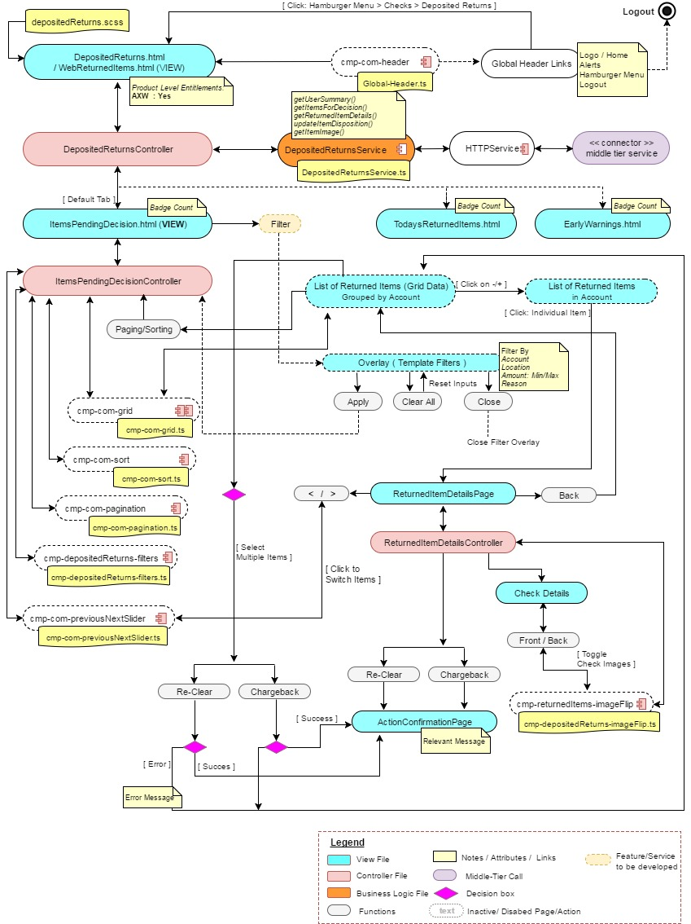

##### **Middle-Tier Interaction (Sequence Diagram)**

The below diagram represents the getUserSummary() call from the UI to the middle-tier and then backend service to get tab counts for depositedItemsReturnPage. getItemsForDecision(), getReturnedItemDetails() and getItemImage() calls from UI to the middle-tier and then backend service to get All Items and Details for the selected Items for ItemsPendingDecision tab. Details of the service definition is available from the below link.



#### **Todays Returned Items (Ref- BR 8.04 UC 2 – Todays Returned Items)**

##### **UI-Interaction**

The below diagram represents the UI interaction for the Deposited Items Returned-> TodaysReturnedItems (tab). It shows the different entry points to this UI, various UI components and the different interactions b/w these components.

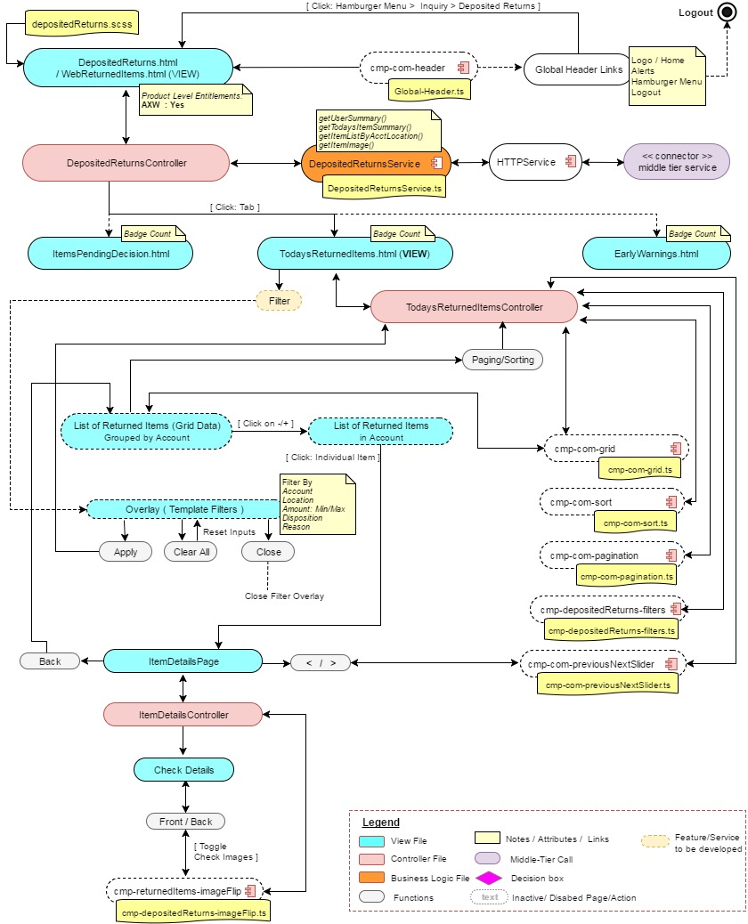

##### **Middle-Tier Interaction (Sequence Diagram)**

The below diagram represents the getUserSummary() call from the UI to the middle-tier and then backend service to get tab counts for depositedItemsReturnPage. getTodaysItemSummary(), getItemListByAcctLocation() and getItemImage() calls from UI to the middle-tier and then backend service to get AllItems and Details for the selected Items for TodaysReturnedItems tab. Details of the service definition is available from the below link.



#### **Early Warning Return Items (Ref- BR 8.04 UC 3 – Early Warning return items)**

##### **UI-Interaction**

The below diagram represents the UI interaction for the Deposited Items Returned-> EarlyWarningReturnItems(tab). It shows the different entry points to this UI, various UI components and the different interactions b/w these components.

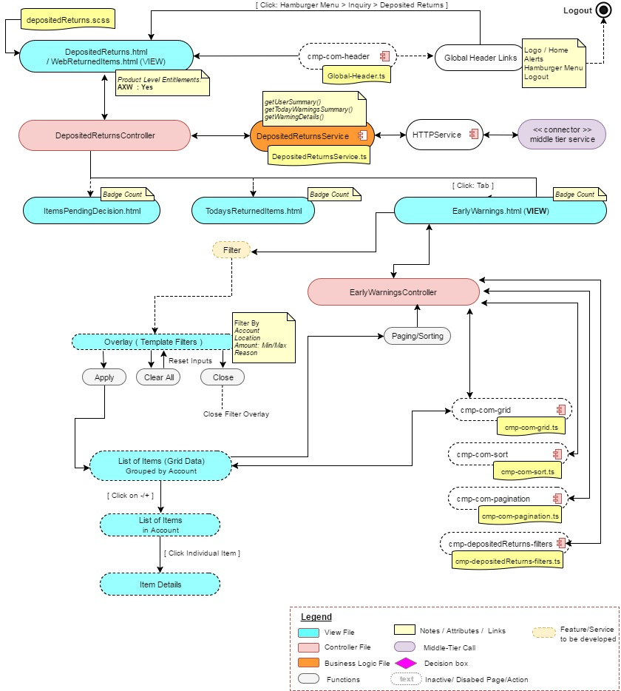

##### **Middle-Tier Interaction (Sequence Diagram)**

The below diagram represents the getUserSummary() call from the UI to the middle-tier and then backend service to get tab counts for depositedItemsReturnPage. getTodayWarningsSummary() and getWarningDetails() calls from UI to the middle-tier and then backend service to get AllItems and Details for the selected Items for EarlyWarningReturnItems tab. Details of the service definition is available from the below link.



# Service Interfaces

The service information is captured in the attached excel sheet. Refer the attached excel sheet for all the service related information’s. The sheet includes service interfaces that will be developed as new service API from the middle-tier. Along with the backend service details.



# Business Rules and Use-Case Mapping

The following link provides the business rule mapping with the use case from the functional spec document.

